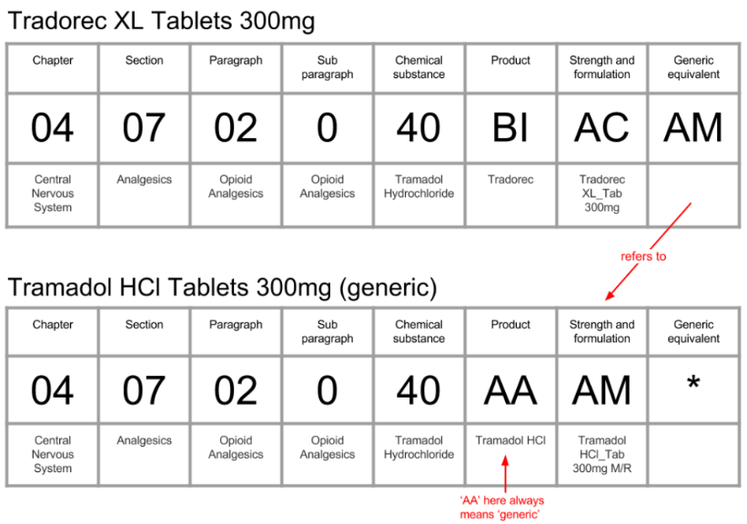

(branded)

Primary Key for branded_list

Primary Key for generic_list

BNF Code Character 1-9 + Character 12+13

BNF Code Character 1-9 + Character 14+15